**Practical : 10**

**Aim :** Using Impala Tool

Impala is an open-source, distributed SQL query engine that runs on top of the Hadoop Distributed File System (HDFS). Impala is designed for interactive SQL queries on large datasets and provides real-time querying of Hadoop data.

Impala supports a wide range of SQL commands and can be used with various Business Intelligence (BI) tools, such as Tableau and MicroStrategy. Impala provides a fast and flexible way to query data stored in Hadoop.

**Some of the key features of Impala are:**

**High Performance:** Impala uses a distributed architecture that enables it to perform SQL queries on large datasets in real-time. Impala is highly optimized for Hadoop and can execute SQL queries faster than other SQL-on-Hadoop engines.

**SQL Compatibility:** Impala supports a wide range of SQL commands and is compatible with standard SQL syntax. This makes it easy for SQL developers to use Impala without having to learn a new query language.

**Integration with Hadoop Ecosystem:** Impala is integrated with the Hadoop ecosystem and can be used with various Hadoop components such as HDFS, Hive, and HBase. This integration enables Impala to access data stored in these systems and perform queries on them.

**Security:** Impala provides a comprehensive security model that includes authentication, authorization, and audit logging. This ensures that data is protected and only authorized users can access it.

**Some of the commonly used Impala SQL commands are:**

**SELECT: Used to retrieve data from one or more tables.**

**Syntax: SELECT column1, column2 FROM table_name**

**WHERE: Used to filter data based on a condition.**

**Syntax: SELECT column1, column2 FROM table_name WHERE condition**

**JOIN: Used to combine data from two or more tables.**

**Syntax: SELECT column1, column2 FROM table1 JOIN table2 ON table1.column = table2.column**

**GROUP BY: Used to group data based on one or more columns.**

**Syntax: SELECT column1, COUNT(column2) FROM table_name GROUP BY column1**

**ORDER BY: Used to sort data in ascending or descending order.**

**Syntax: SELECT column1, column2 FROM table_name ORDER BY column1 ASC/DESC**

**Overall, Impala is a powerful SQL-on-Hadoop engine that provides high-performance querying of large datasets stored in Hadoop. Its SQL compatibility and integration with the Hadoop ecosystem make it a popular choice for interactive data querying and analysis.**

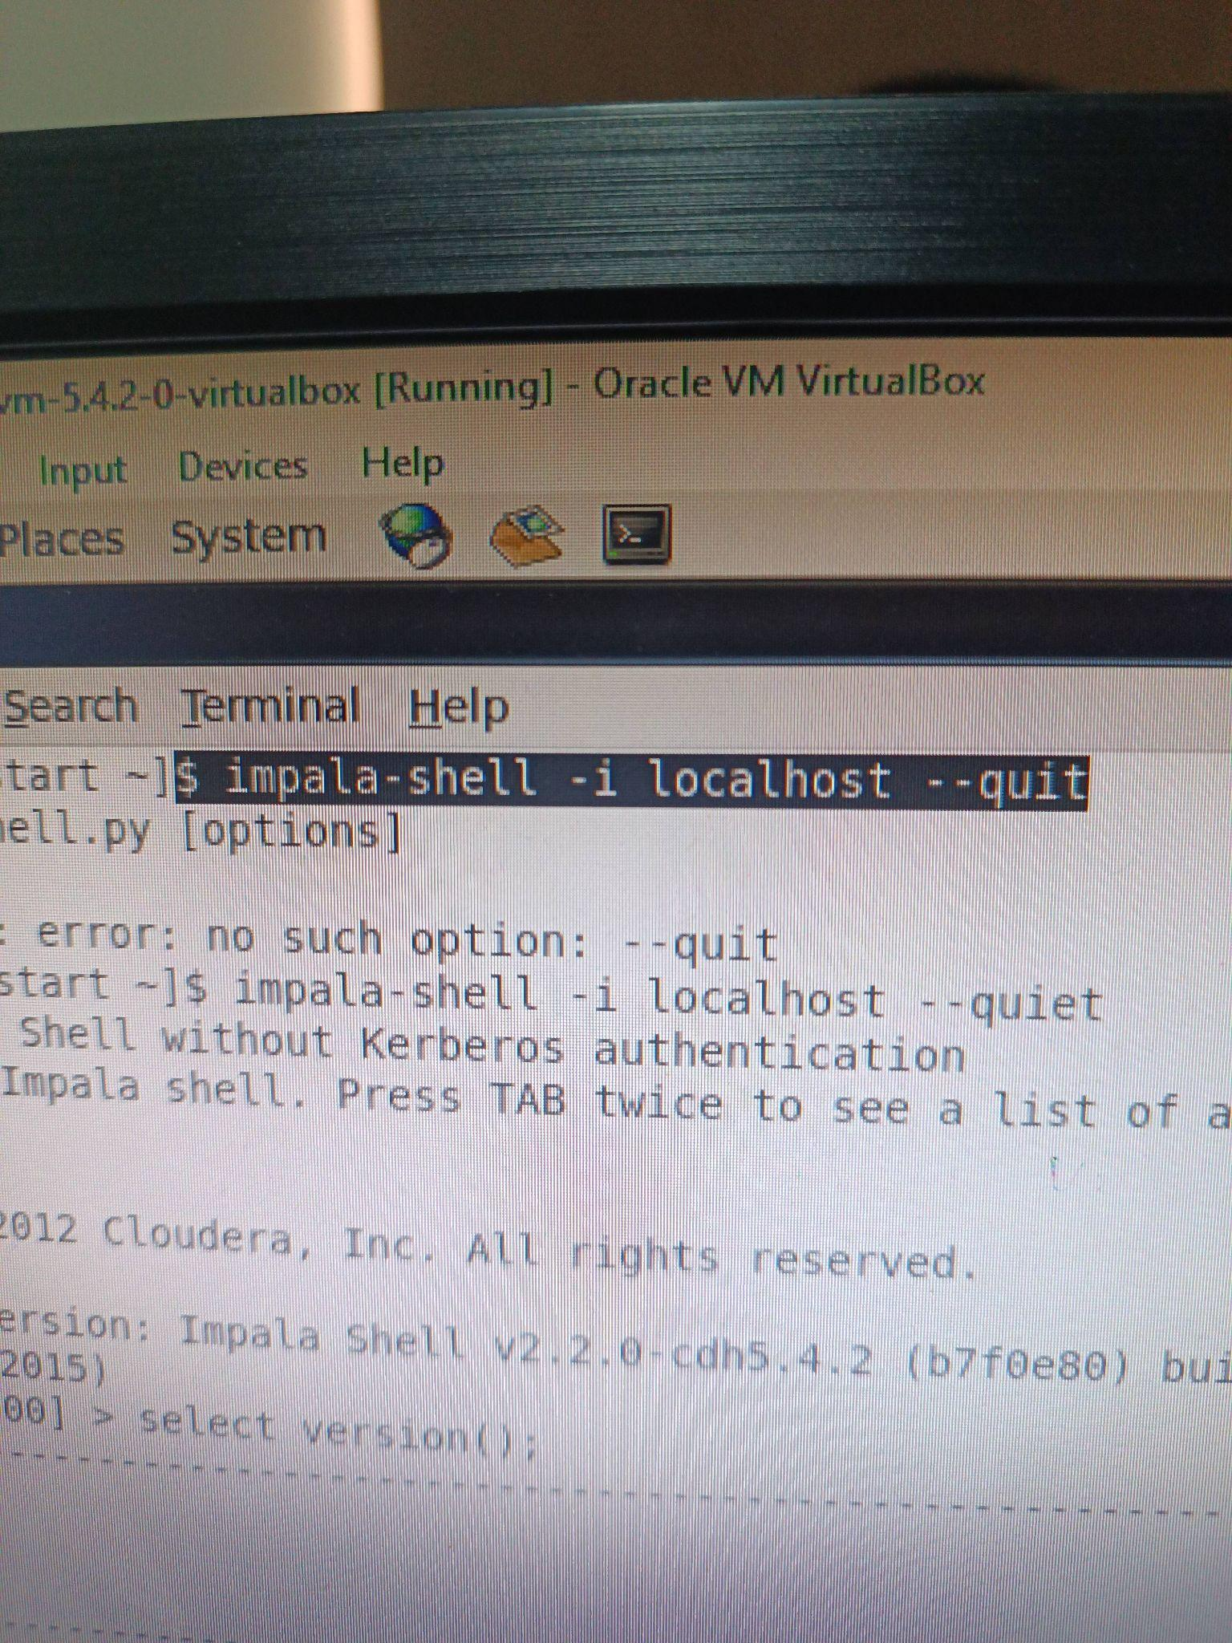

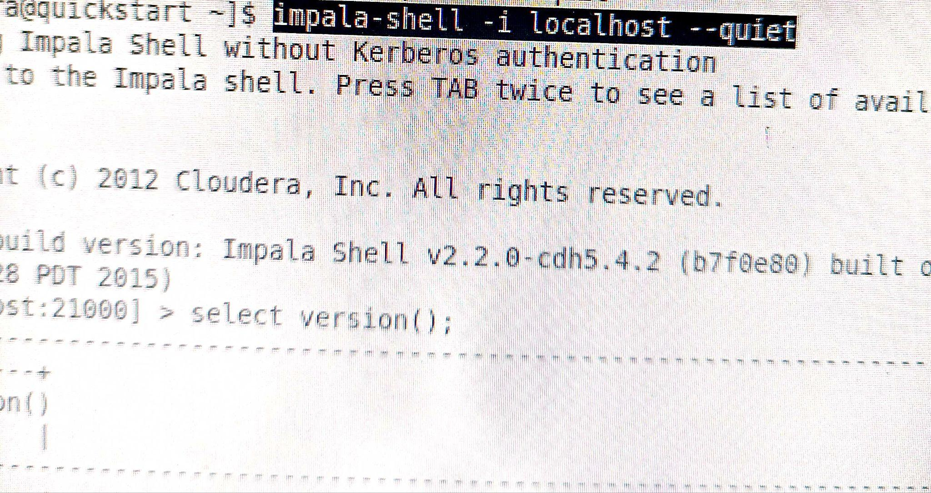

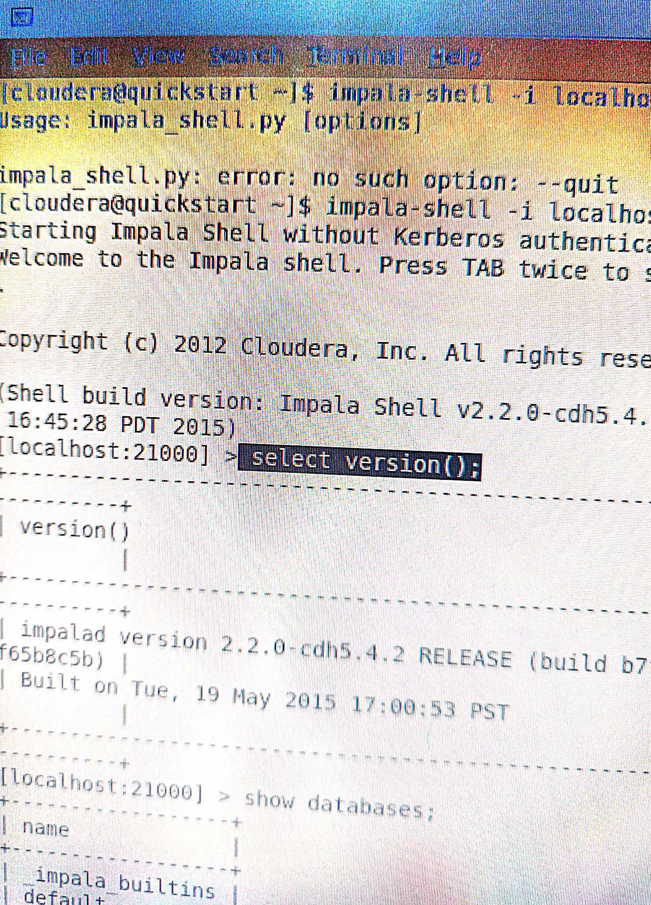

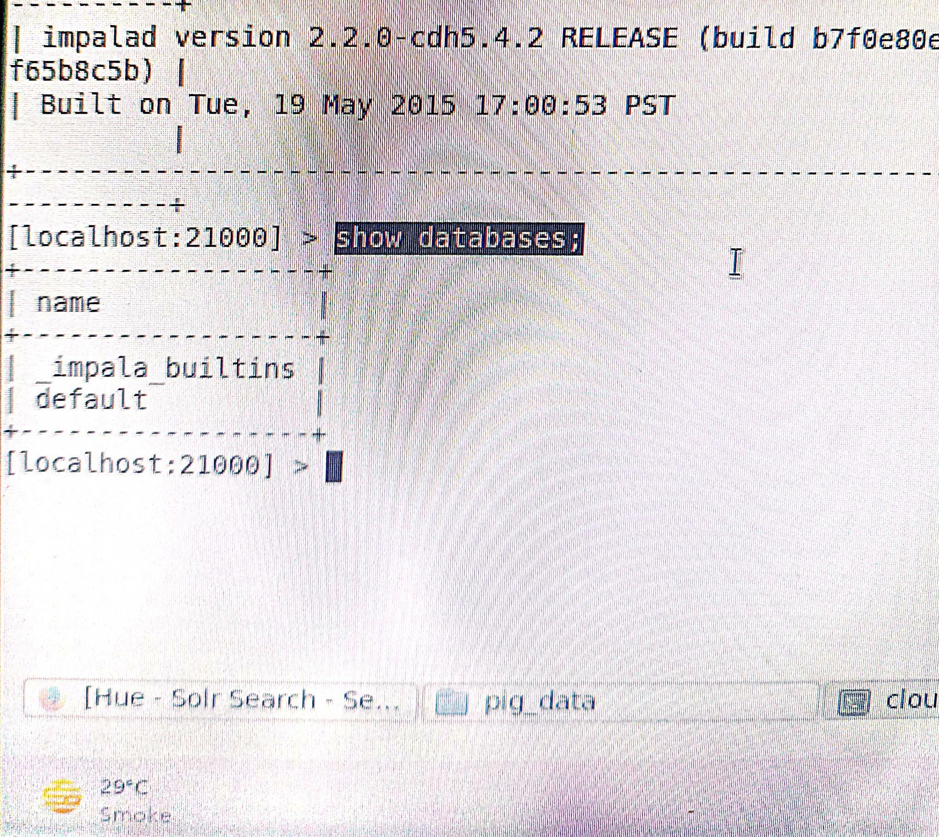

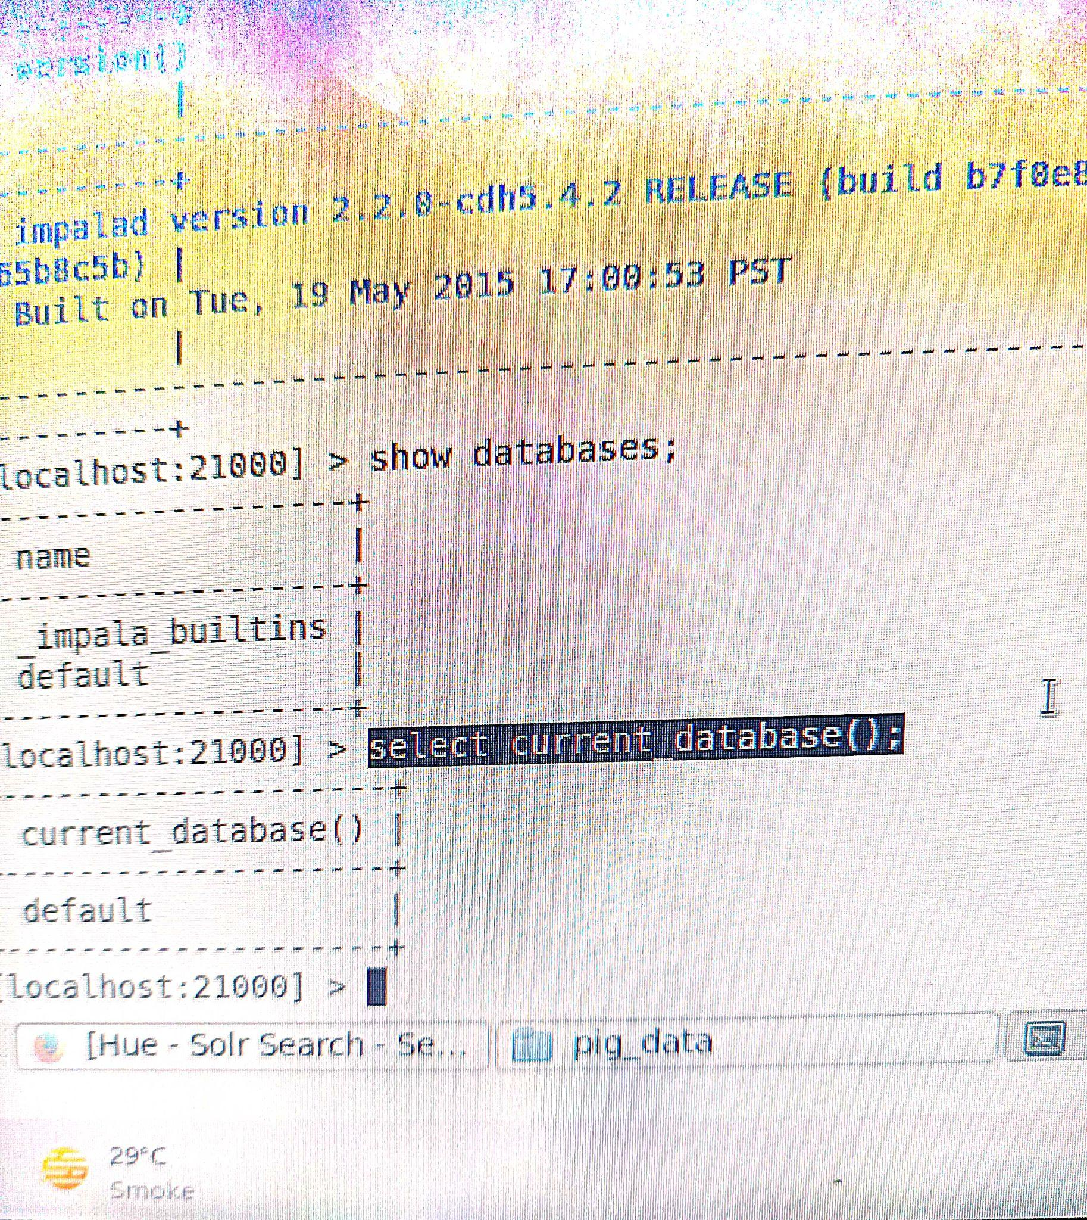

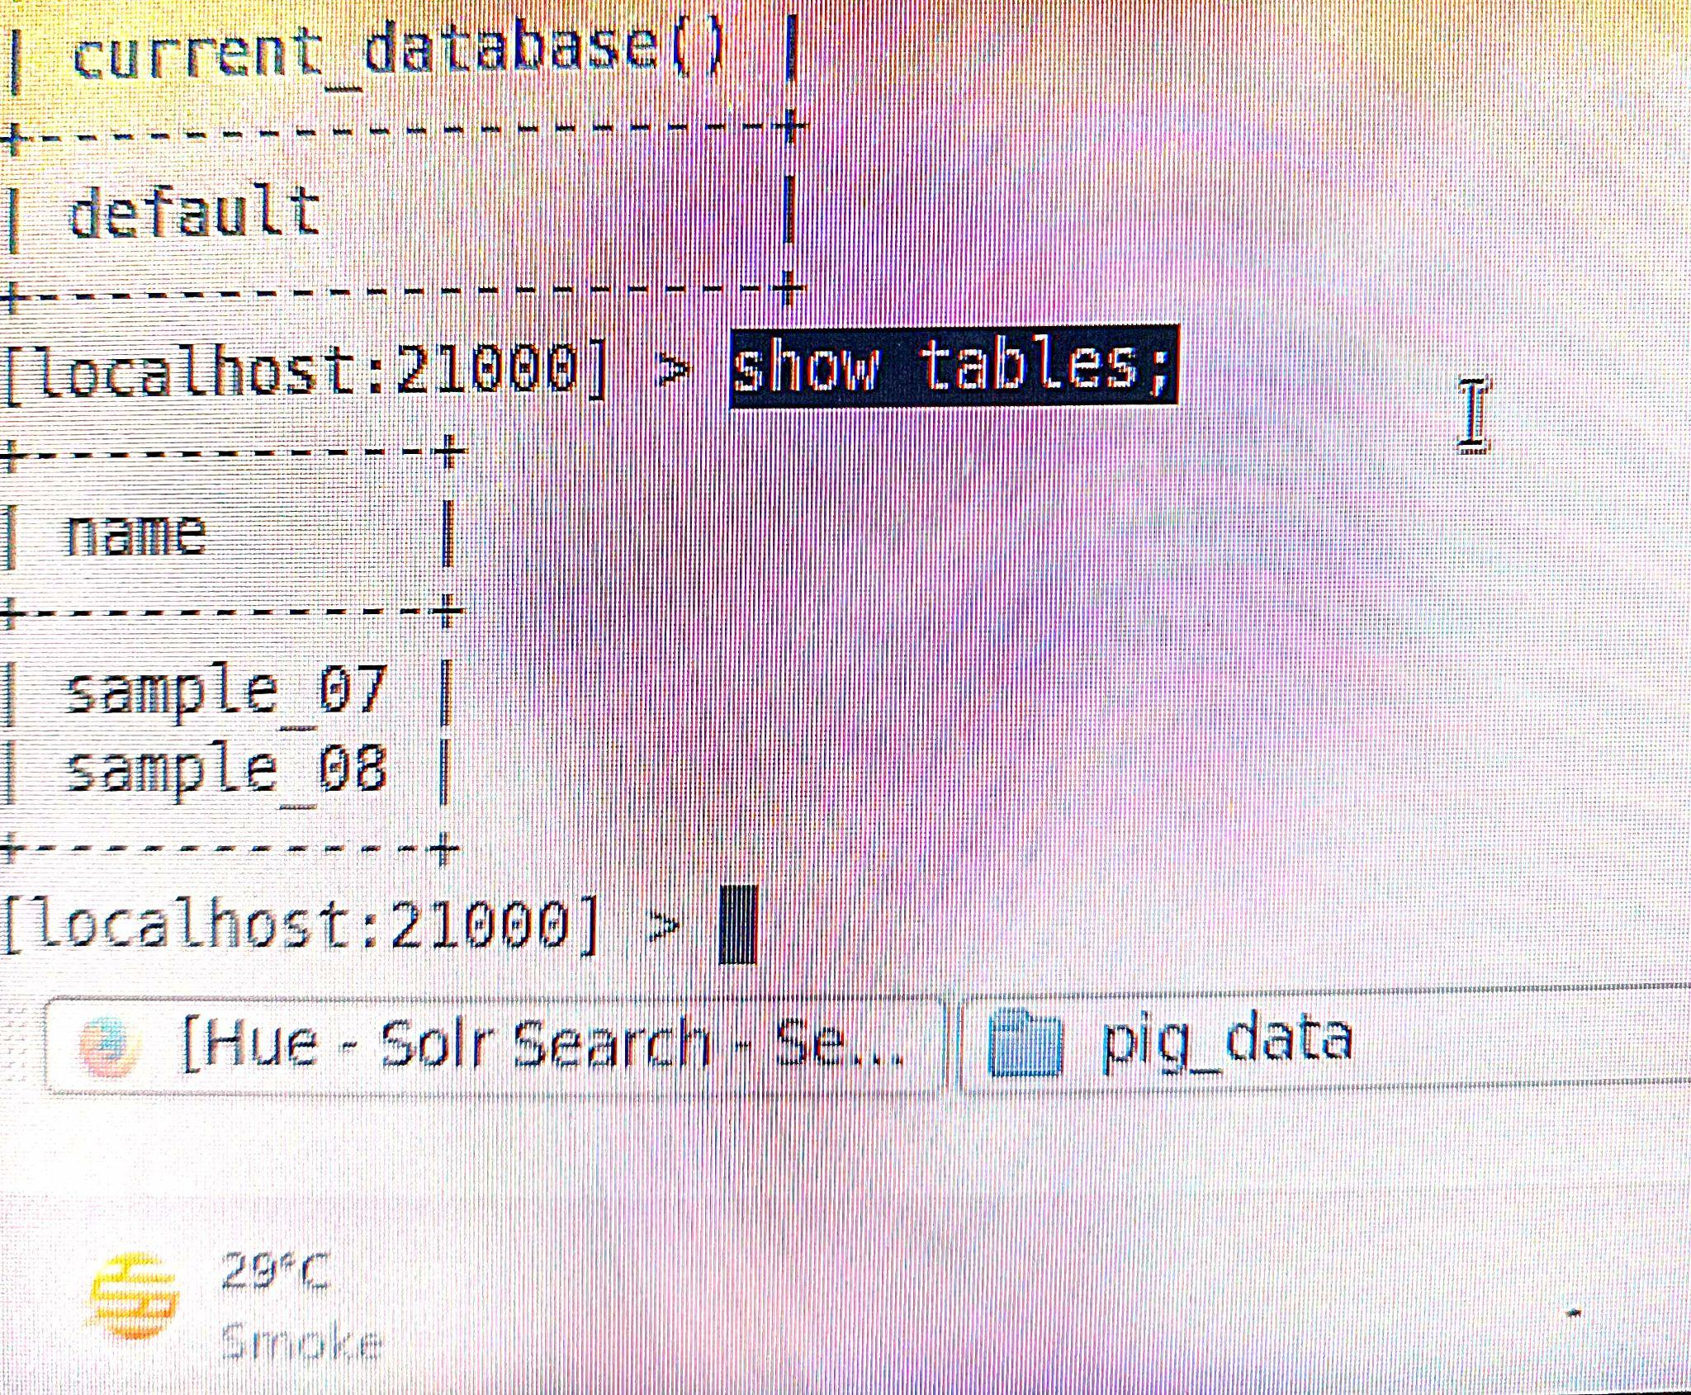

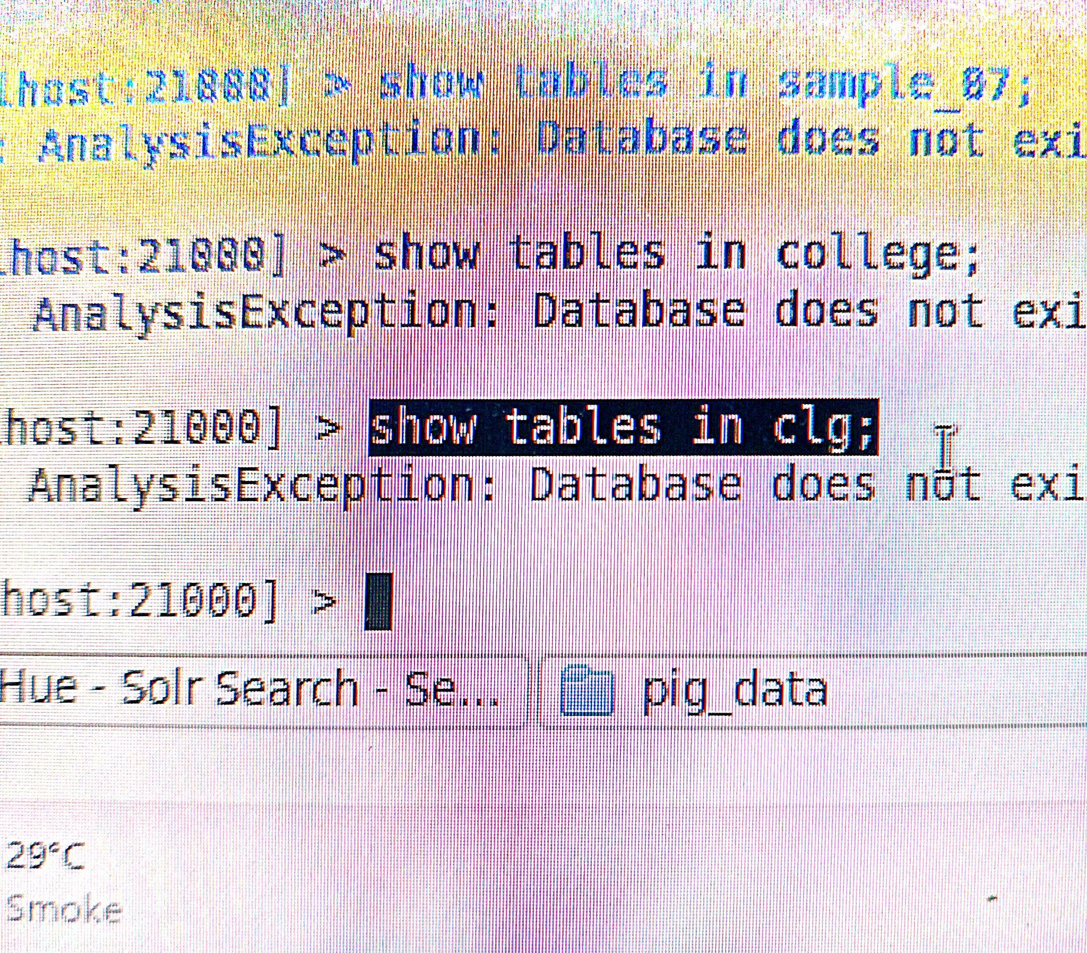

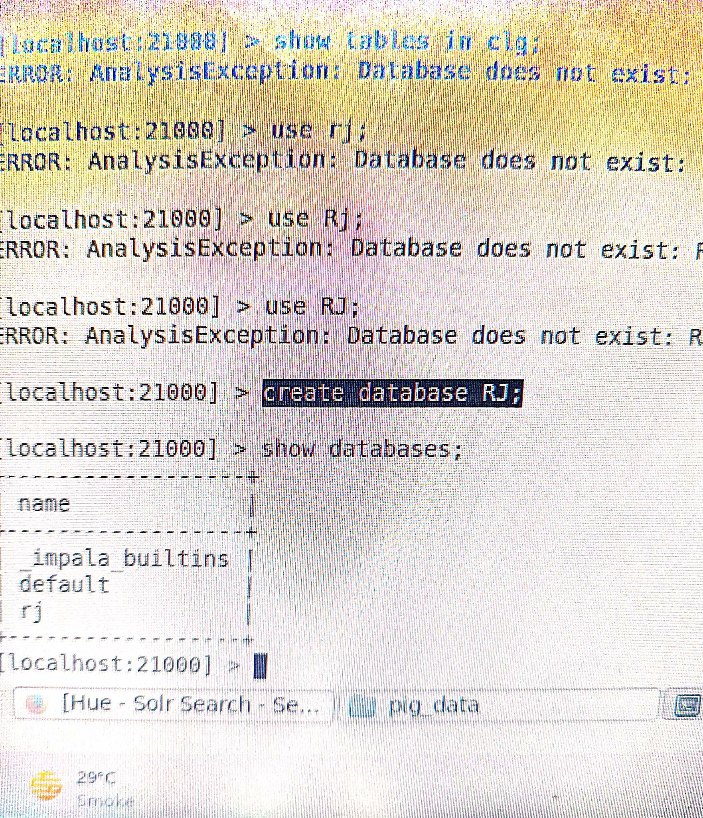

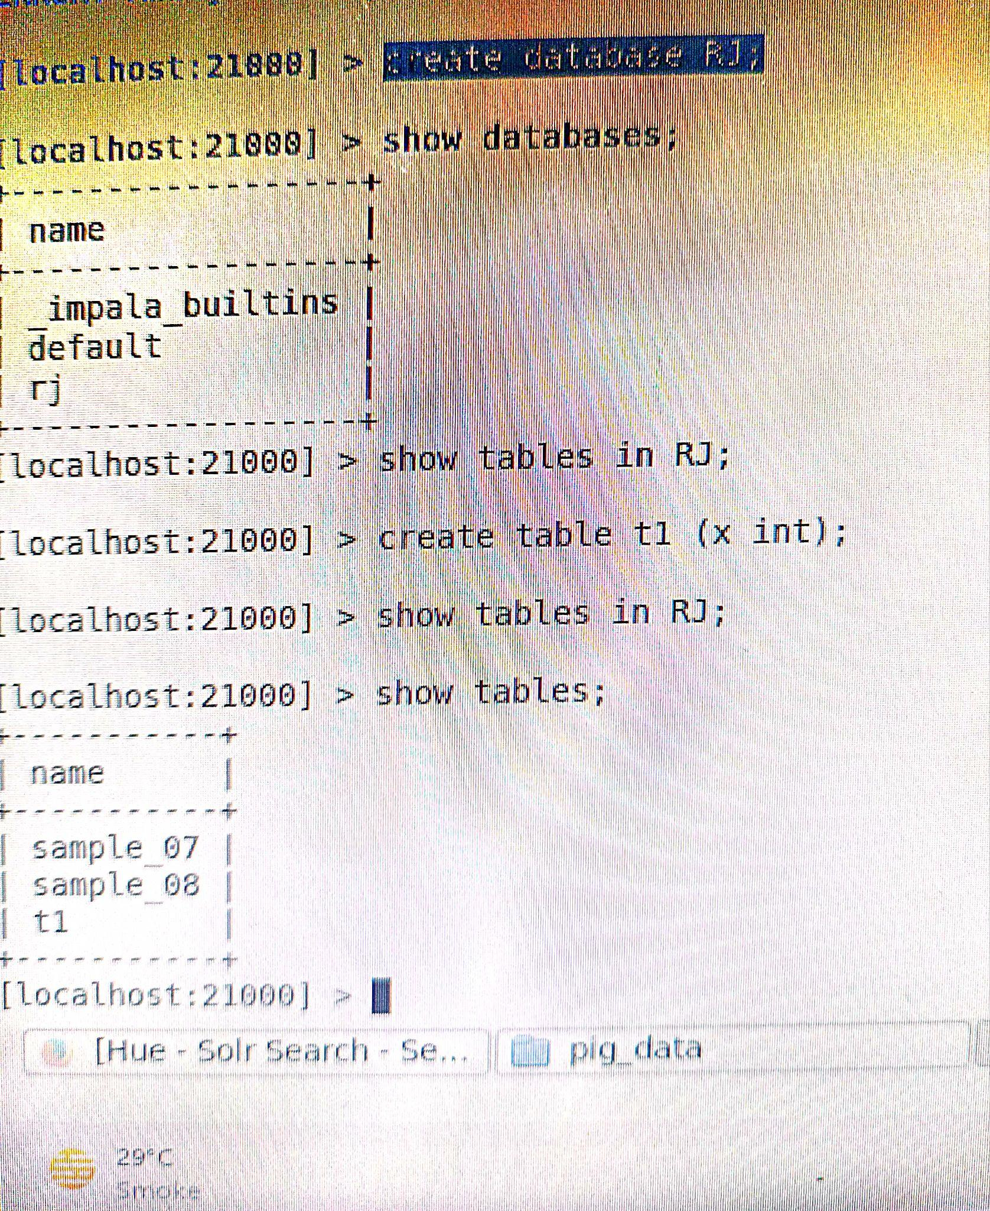

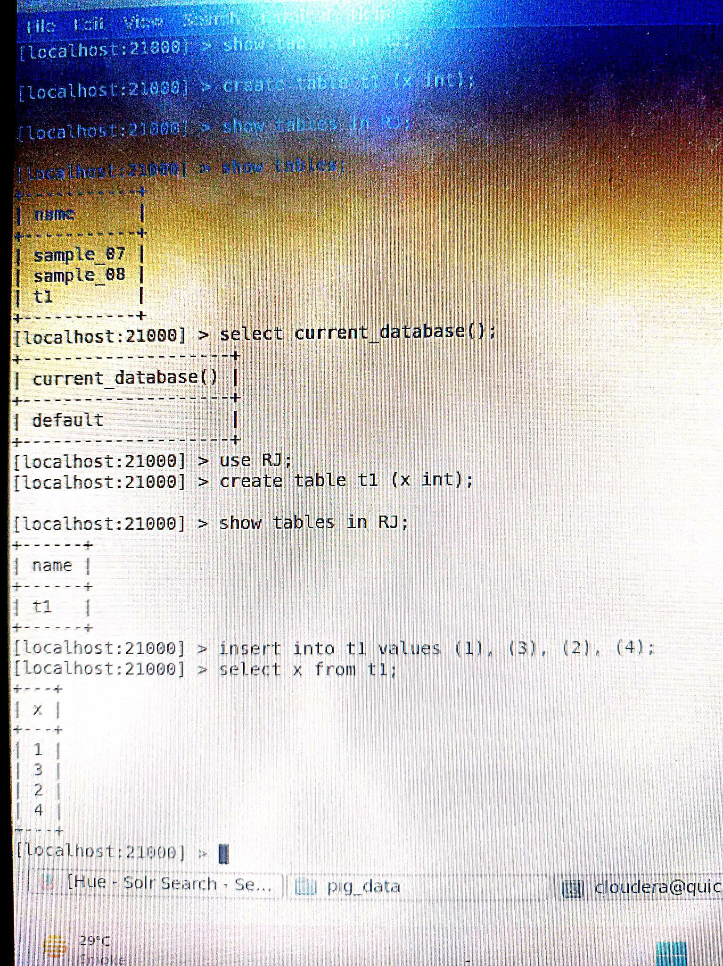

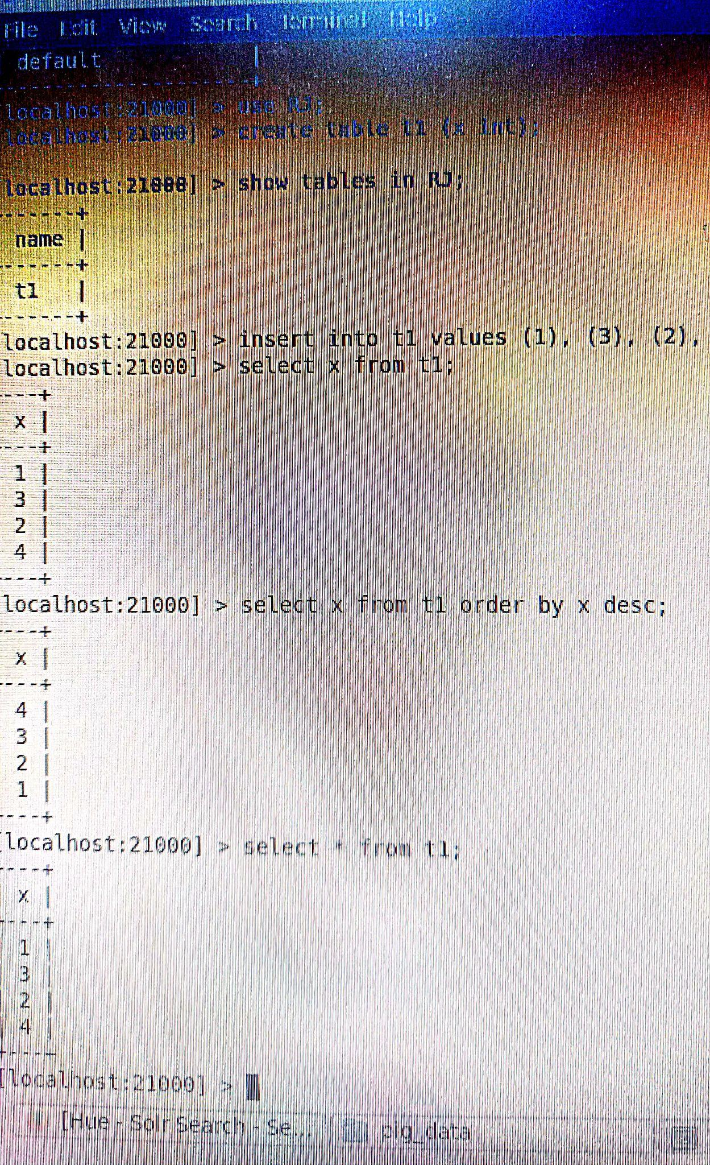

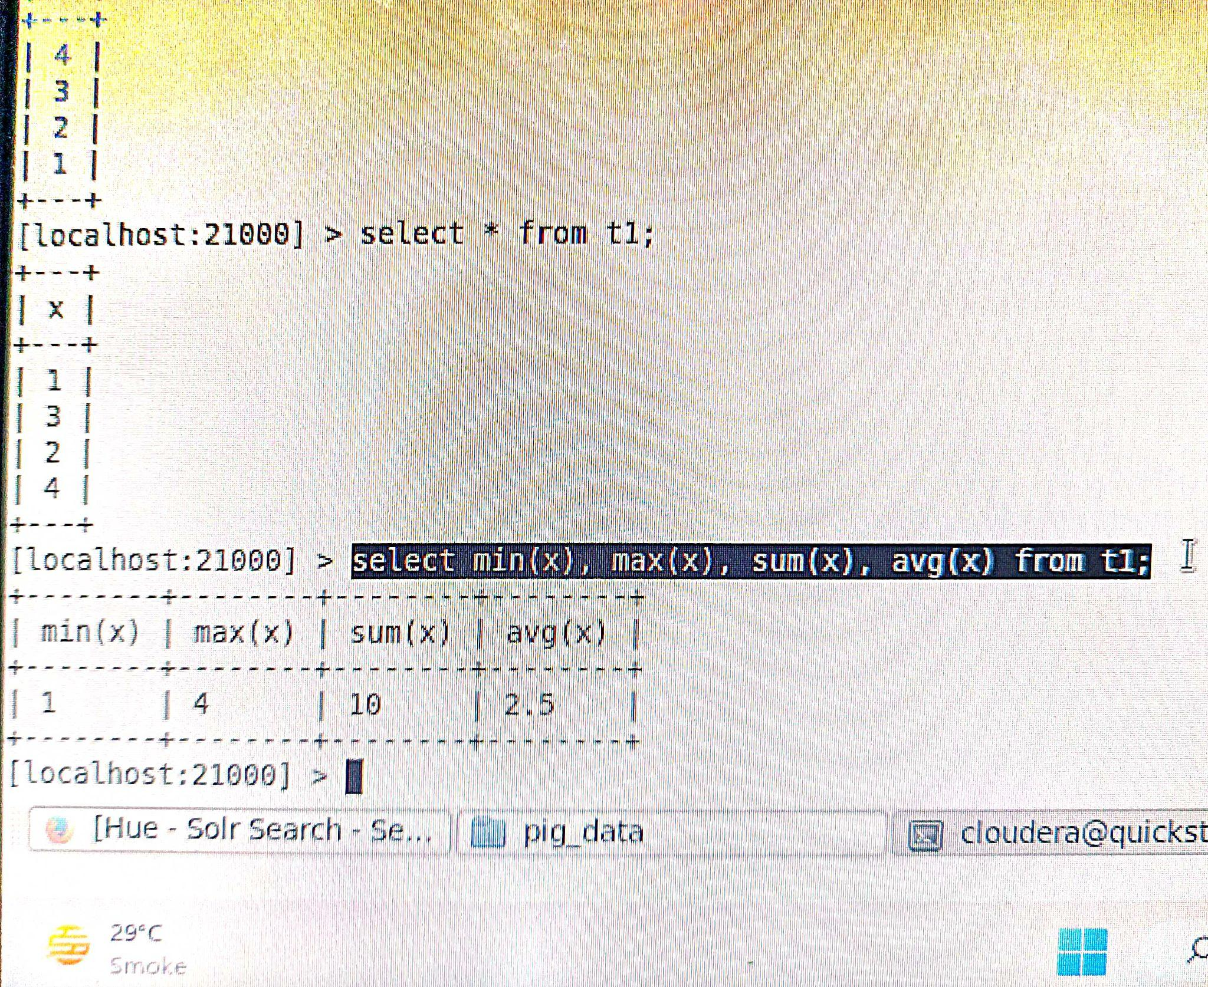

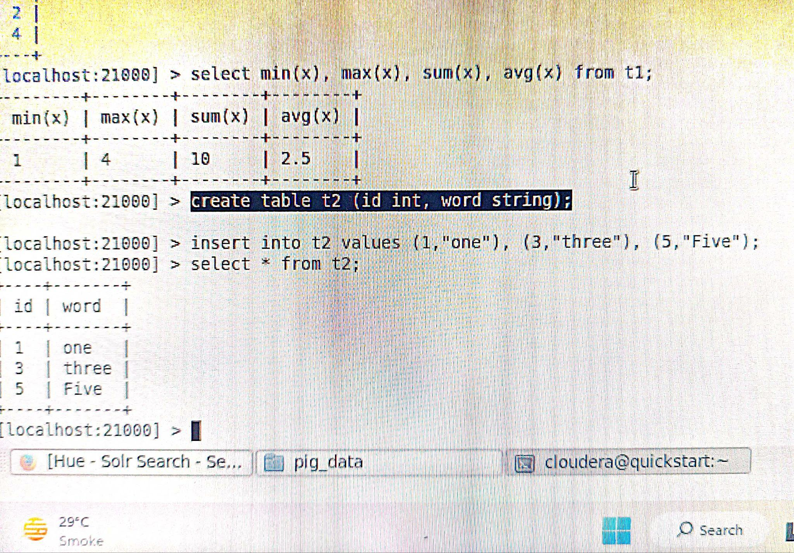

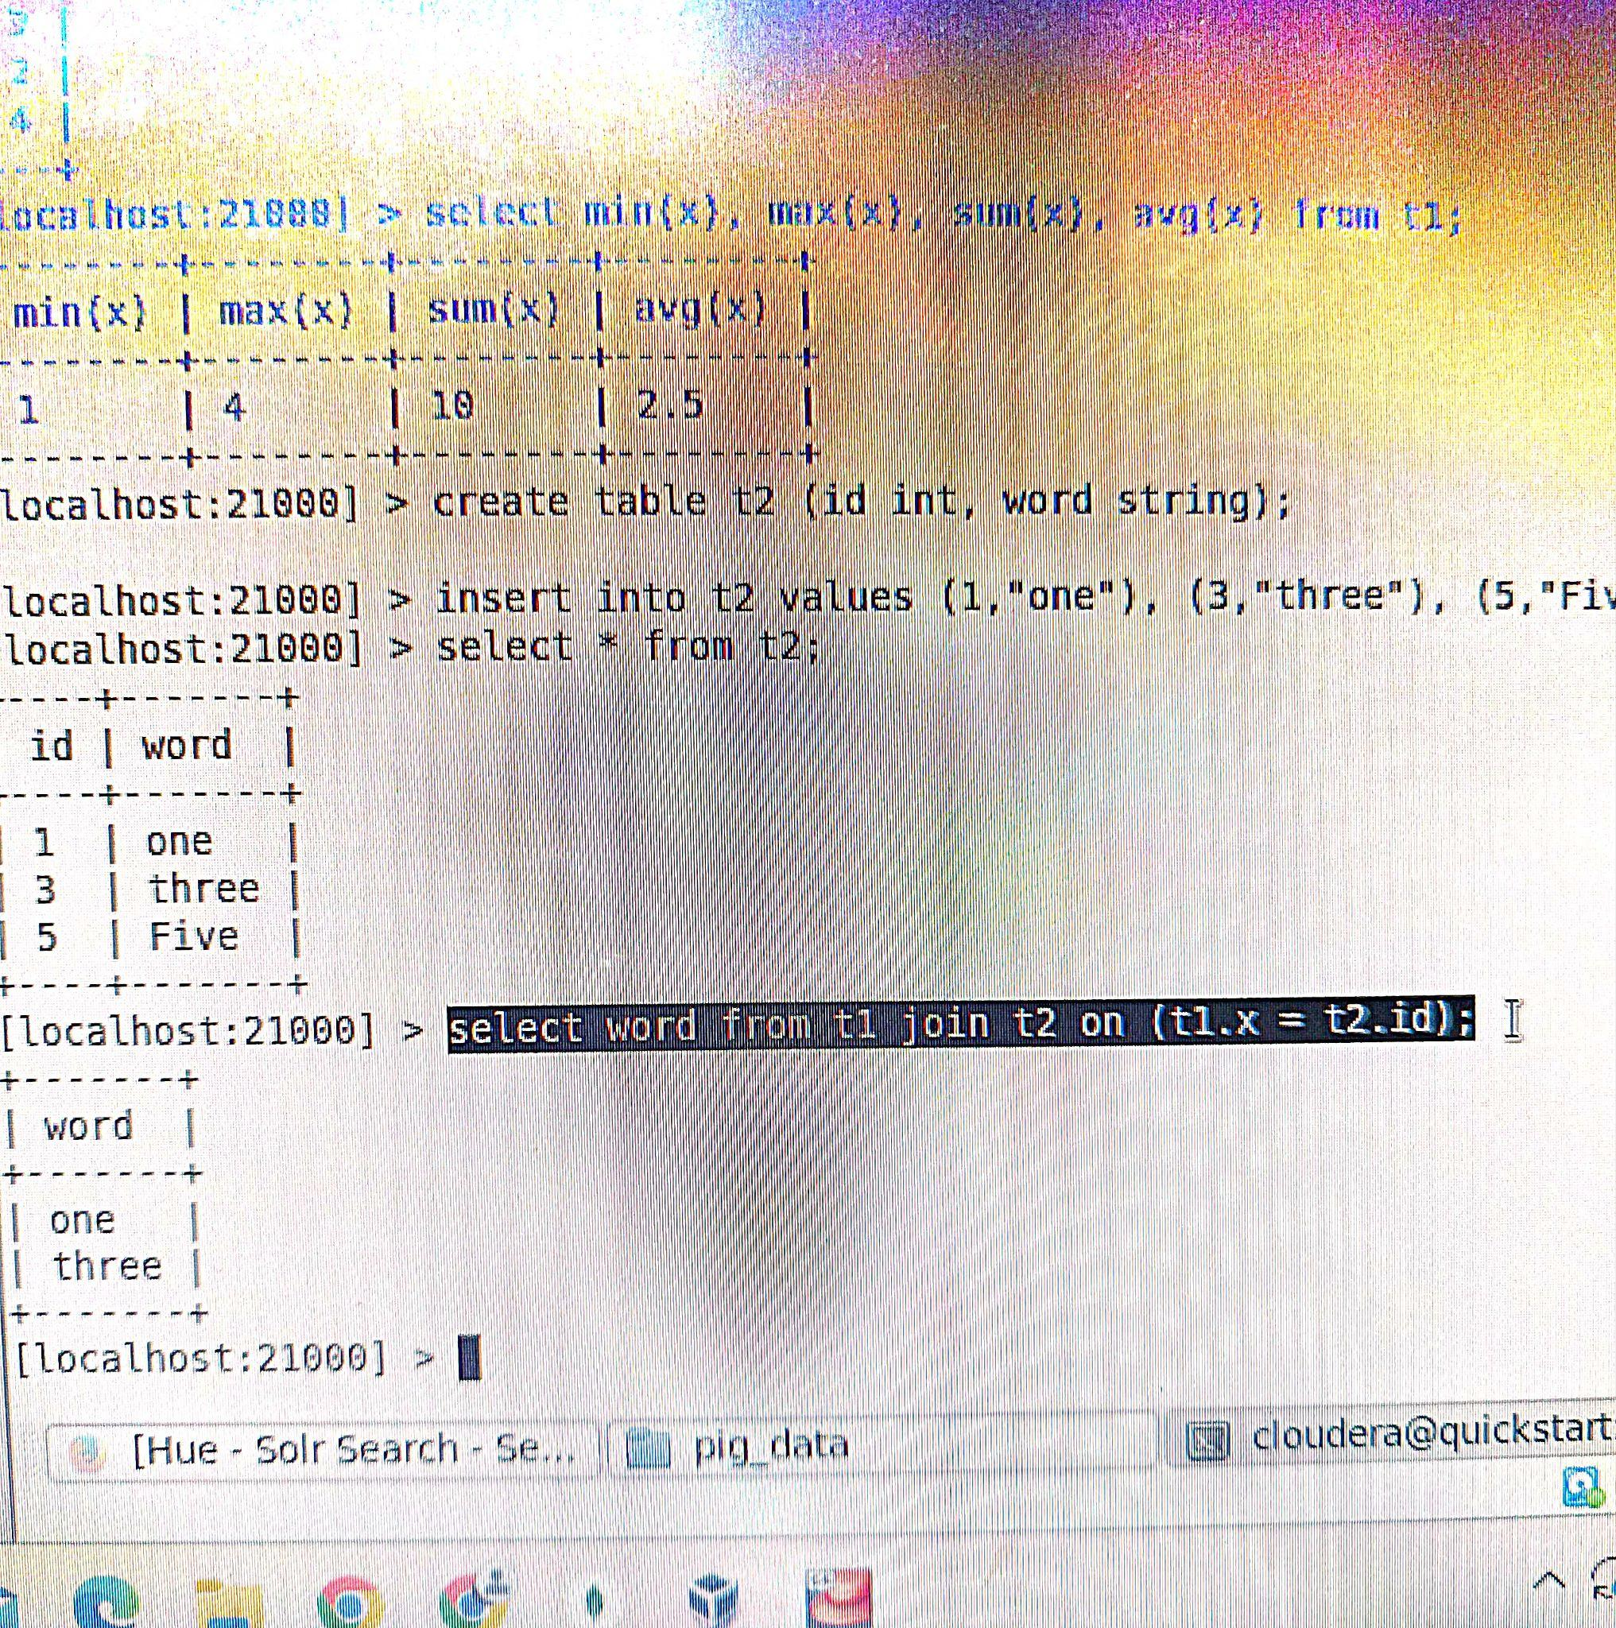

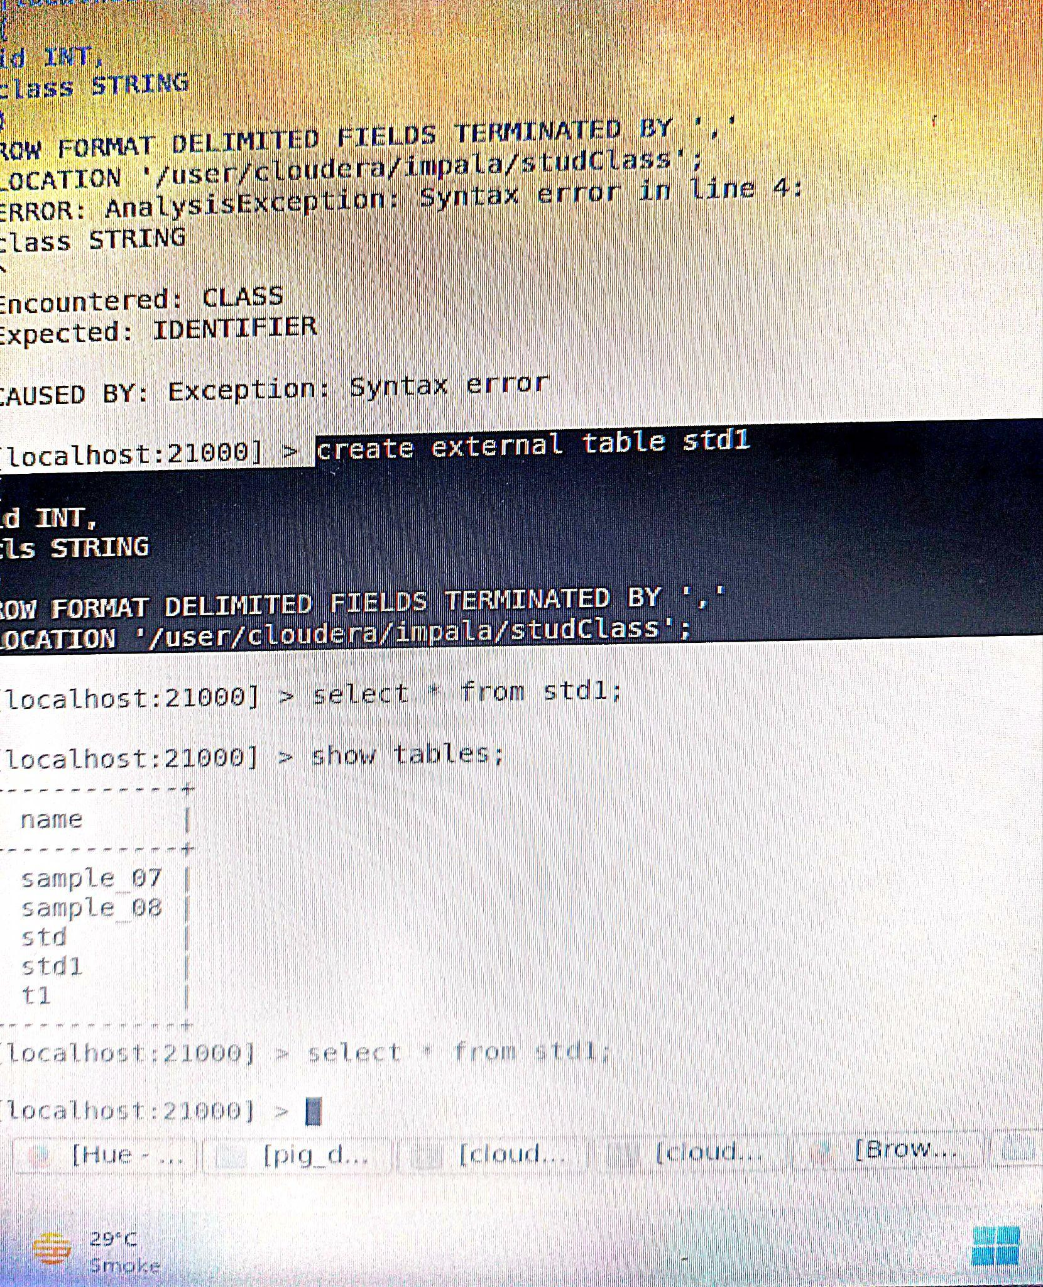

**Done**